SECURITY PRO USA
Security 20/20, Inc. d/b/a Security Pro USA
8543 Venice Blvd, Los Angeles, CA 90034 | GSA Schedule GS-07F-0577T | CAGE 3R0M2
PRISONER ANTI-SCAPE STUN BELT
Models STSB-2233 (Nylon) / STSB-1250 (PVC Waterproof)
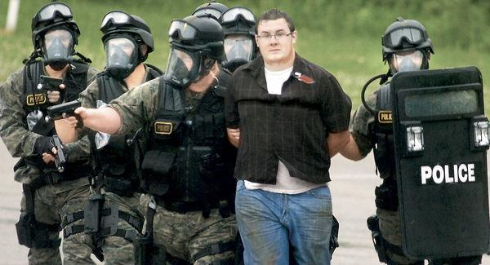
Complete kit: belt, control box, charger, dual-button remote, and carry bag
Overview
The Anti-Scape Stun Belt restrains and controls the behavior of prisoners and aggressors during escort, reducing the risk of escape while protecting officers, staff, and bystanders from violent attacks — with a goal of restoring order using minimum force.
Key Features  - Control range up to 100+ meters (line of sight, environment-dependent)  - 125-dB siren as first-stage audible warning before shock activation  - Non-lethal high-voltage pulse with pre-set cut-off timer for shock duration  - Sequential, colour-coded dual-button remote: siren first, shock deterrent second  - Concealed in-belt cabling offers cut resistance against a knife  - Dual heavy-duty Velcro restraint straps with handcuff D-ring for secure fit  - Base belt: high-density anti-bacterial polyester, Cordura Nylon cover, 1200D pouch  - New option: Model STSB-1250 with PVC waterproof outer belt  - High-capacity Li-ion battery option for extended standby during escort or transport  - Optional Audit Intel feature: PC interface + software log of belt operation/use  - Cordura carry bag with dual zip sliders and adjustable shoulder strap  - Removable, factory-sealed control box for low-cost shipping and maintenance  - 12-month manufacturer's warranty | 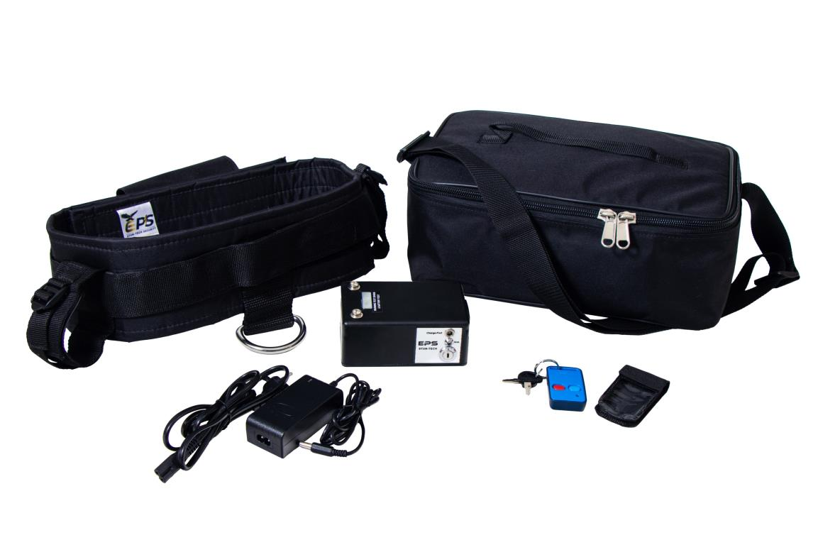  Controlled escort in a tactical setting

TECHNICAL SPECIFICATION
Prisoner Anti-Scape Stun Belt — Models STSB-2233 / STSB-1250
1. General
Used by law enforcement, security personnel, and corrections staff on duty for escorting prisoners and dangerous or violent persons who intend to escape or resist arrest. Intended to protect personnel and bystanders from violent attacks and to help restore order with minimum force.
2. Energizer & Construction
- Open discharge output of 130,000 volts under 500-ohm load, up to 2.5kV pulse, pulse duration under 1ms, average current under 1mA
- Long-range micro receiver with dual-button remote, up to 120m line-of-sight (environment-dependent); non-licensed 434MHz operating frequency; optional back-up remotes
- Preset sequential safety activation via colour-coded remote: Blue = 125dB warning siren (1st stage); Red = time-out shock deterrent (2nd stage)
- Key switch ON/OFF with standby light indicator
- Standby time 120+ hours; operating time 8+ hours continuous, or up to 300 sequential activations
- Base belt: combined D600/D1200 nylon with heavy-duty cut-resistant inner lining; 8mm thick × 1200mm long × 110mm wide; concealed pouch houses the energizer box
- Model STSB-1250 option: PVC waterproof outer covering
- Concealed in-belt cabling conducts the shock deterrent and resists knife cutting
- Seat-belt-webbing tightening through a nylon 3-bar slide buckle, secured further with Velcro closure
- Webbing straps also secure the wrist/forearm; heavy-duty ring for handcuffs or belly/ankle chain
- Sealed, detachable control box houses all electronics, battery pack, ON/OFF switch, and standby indicator
- Test-spark warning and low-voltage battery indicator
- Heavy-duty D600 nylon carry bag included
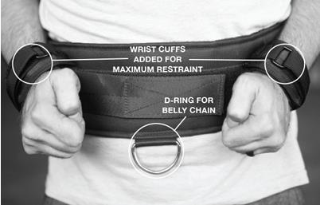
Wrist cuff and belly-chain D-ring attachment points
3. Power Source
- High-capacity 7.2V, 1000mAh NiMH rechargeable battery pack
4. Charger
- Plug-in charger, 220/110V AC 50/60Hz input, two-pin round plug
- Intel charger indicates battery level and charge state
5. Warranty
- 12-month manufacturer's warranty
- Factory-sealed, removable control box for easy maintenance and repair
6. Packaging
- Standard double-wall carton, 620 × 460 × 340mm, 4 stun belts per carton, 12kg packed weight

